BUG-01
[Login] Error message text is cut off inside the red error box, after logging in with a wrong password, while user is logged out
Description:
The invalid credentials error message is longer than its red box, so the first and the last lines of the text are partly hidden.
Environment: Web - Chrome, Windows, https://www.saucedemo.com
Preconditions:
1. User is logged out
Steps:
1. Open https://www.saucedemo.com
2. Enter username "locked_out_user"
3. Enter password "12"
4. Click Login
Expected result:
1. The message "Epic sadface: Username and password do not match any user in this service" is displayed in full
2. The whole text stays inside the red error box
Actual result:
1. The message needs three lines, but the red box fits only two lines
2. "Epic sadface:" is partly cut at the top of the box and "this service" is partly cut at the bottom
Attachments:
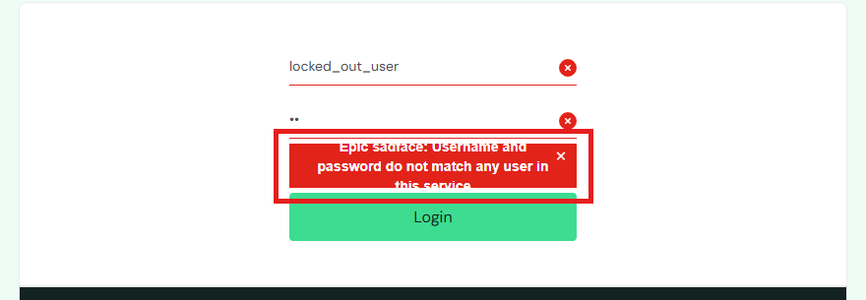
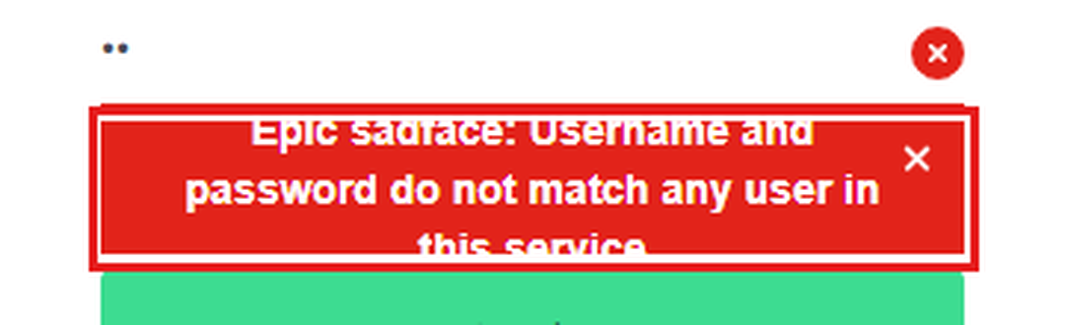
Severity: Low
Priority: Medium

